Bud(i)

*We show you who is listening. The rest is on you…*

The music sharing app that promotes REAL interaction.

**Problem**: We are amid an electronic intellectual age; technology now has a place in every human interaction. Commuters and strangers rarely interact unless prompted to, eye contact is averted, and people keep to scrolling and liking distant images. A room can be filled with people all plugged into their own devices; everyone consumed and distracted from the immediate lives around them.

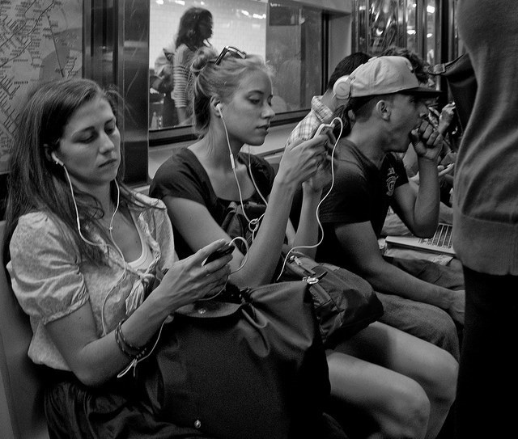

While the effects of technology on our society are trending positively: improving medicine, communication, transportation, food source, renewable energy etc.… there is one major aspect to the human experience that technology seems to be neglecting ...

This is our **interpersonal connection**: our ability to realize the value of immediate social situations and foster appropriate responses with those surrounding us. A positive interpersonal relationship fosters self-esteem, understanding, curiosity, as well as empathy.

As the world continuously connects, more and more global events become immediately relevant, people become inundated with information, overwhelmed stuck scrolling and clicking and feeling hopeless, building personas and hoping for distant messages.

This absence of local immediate interaction creates niche of opportunity. An opportunity for a series of electronic adaptations, that can bridge the gap between strangers and foster empathy and communication.

**Solution:**

**Budi,** takes the place that was once the boom-box. Budi allows for strangers to see what others are listening to, as well as join in.

Budi DOES NOT:

-Store personal information (age, gender, etc.!)

-Request personal information from others

-Exceed a 20-foot range. Budi does not care unless its right next to you!

-Does not provide a messaging or facilitate any interaction of buddies, that is where real life social skills must be implemented if warranted.

**Mission:**

Budi is unlike any other social media application. Budi creates a potential for connection, but it does not elaborate any further. Its innocence is its charm and distinguishes it from other more pervasive technology.

Budi fosters human interaction in ways technology seems to be abusively neglecting, the immediate, the local and the simple.

**Potential Aesthetic:**

**Screen 1 Screen 2**

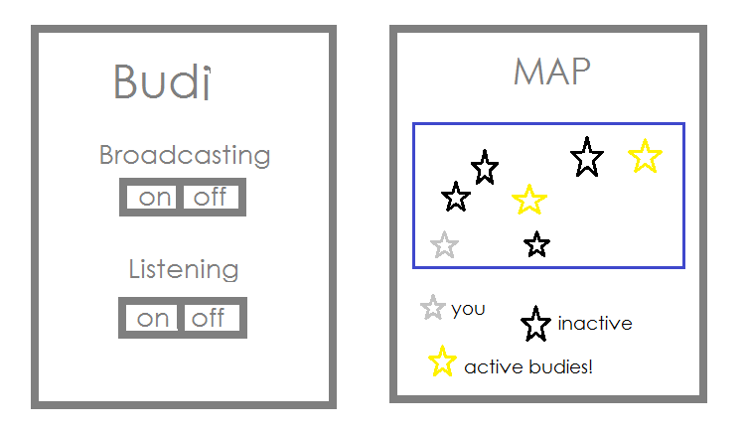

**Potential Uses and commercial scenes:**

**-On subway**

**-Friends on bike ride**

**-On a school bus**

**-In a café**

**-On college campus**

**-In a library**

**-ANYWHERE someone listens to music around strangers!**